Contact: Jessica Letscher, VP Marketing
Gamajet, part of the Alfa Laval Group
604 Jeffers Circle | Exton, PA 19341
Tel: 610.408.9940 | Fax: 610.408.9945
Jessica.letscher@gamajet.com
www.gamajet.com

FOR IMMEDIATE RELEASE

New plant supervisor is “The Big Cheese” after increasing tank turnaround times by enhancing CIP
Ideal for all dairy tank and vat sizes and applications, the Alfa Laval Sani-SB rotary spray tank cleaning devices are all fully 3-A compliant and provide a faster, more efficient clean than standard CIP processes.
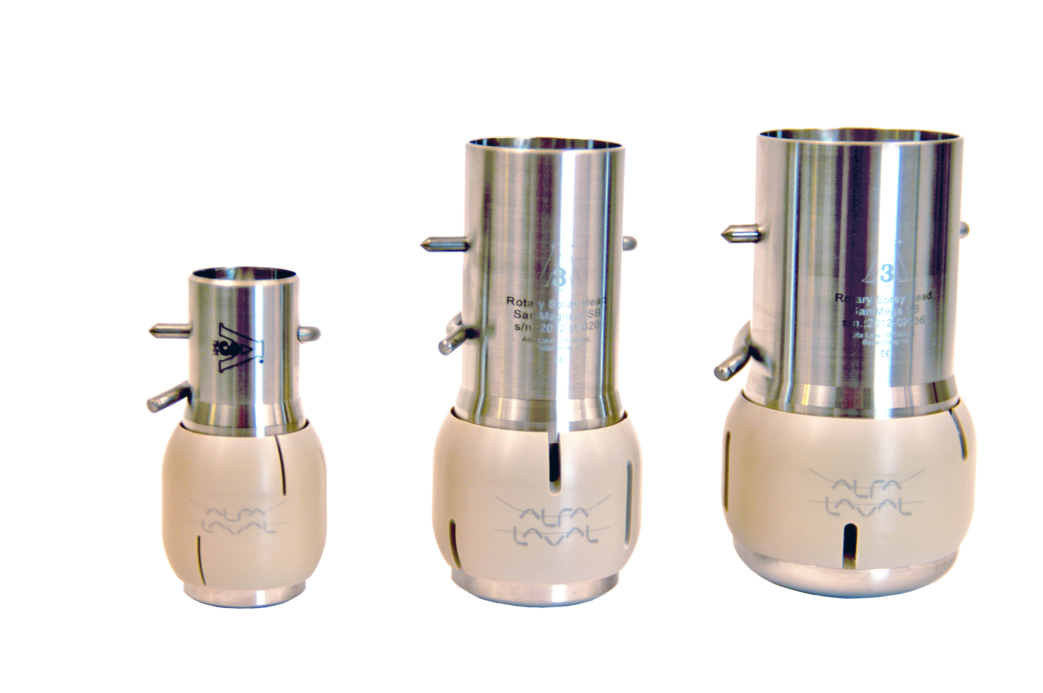
EXTON, PA – A cheese manufacturing company in Wisconsin had been using static spray balls to clean their mozzarella and provolone cooling baths and was frustrated with the slow, inefficient process. Each tank has to meet strict sanitation guidelines of the dairy industry and therefore needs to be cleaned 3-4 times a week. In an effort to increase turnaround times, the company hired a new production supervisor to help streamline their process. The new supervisor had experience with Alfa Laval’s 3-A SB SaniMidget rotary spray head from previous jobs and knew this was the product to optimize their CIP and in turn, increase production times.

He received approval to install SaniMidgets in two cooling baths. There was noticeable difference in tank cleaning times immediately. The company was able to shave off 25 minutes of cleaning time for each tank “and the amount of water and chemical usage we saved was a huge added benefit,” the production supervisor explained.

Because the rotary spray heads were so successful in achieving a faster, more efficient cleaning process, the company is now in the process of installing SaniMidgets three of their cookers as well. The company plans to install a total of 40 SaniMidgets in their plant.

Purchased by Alfa Laval in 2012, Gamajet has been supplying a “Better Way to Clean” all types of tanks and vessels for over 50 years. Gamajet’s rotary impingement cleaning method has become the first choice in cleaning for many of the world’s largest personal care and pharmaceutical manufacturers, breweries, food manufacturers, trucking fleets, municipalities, wineries, and chemical operations. Gamajet's rotary impingement tank cleaning machines combine pressure and flow to create high impact cleaning jets. Cleaning occurs at the point in which the concentrated stream impacts the surface. It is this impact and resulting tangential force that radiates from that point and blasts contaminants from the surface, scouring the tank interior. In conjunction with this impact, the Gamajet is engineered to rotate in a precise, repeatable and reliable, 360-degree pattern. This full-coverage, global indexing pattern ensures the entire tank interior is cleaned, every time. For more information, visit www.Gamajet.com or call 610-408-9940.

####

